1. Install docker

Minimum requirement docker version 17.10, download docker dengan menjalankan perintah :

$ curl -O https://download.docker.com/linux/centos/7/x86_64/stable/Packages/[docker-ce-17.12.1.ce-1.el7.centos.x86_64.rpm](https://download.docker.com/linux/centos/7/x86_64/stable/Packages/docker-ce-17.12.1.ce-1.el7.centos.x86_64.rpm)

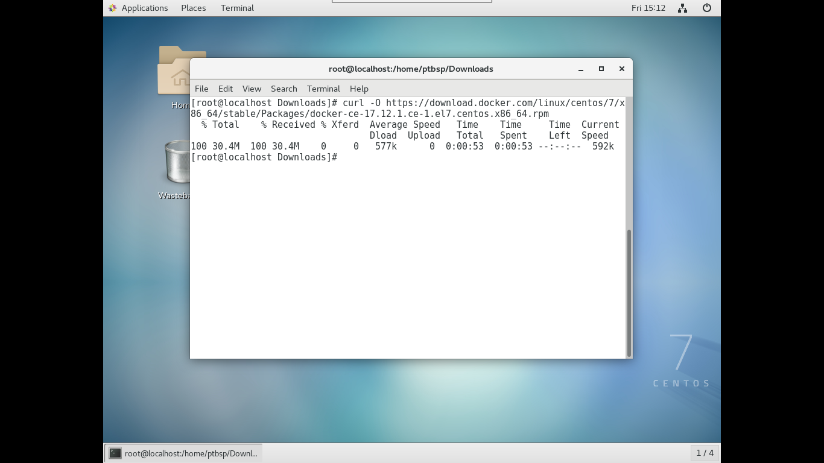

install docker dengan menjalankan perintah :

$ chmod +x docker-ce-17.12.1.ce-1.el7.centos.x86_64.rpm

$ yum install docker-ce-17.12.1.ce-1.el7.centos.x86_64.rpm

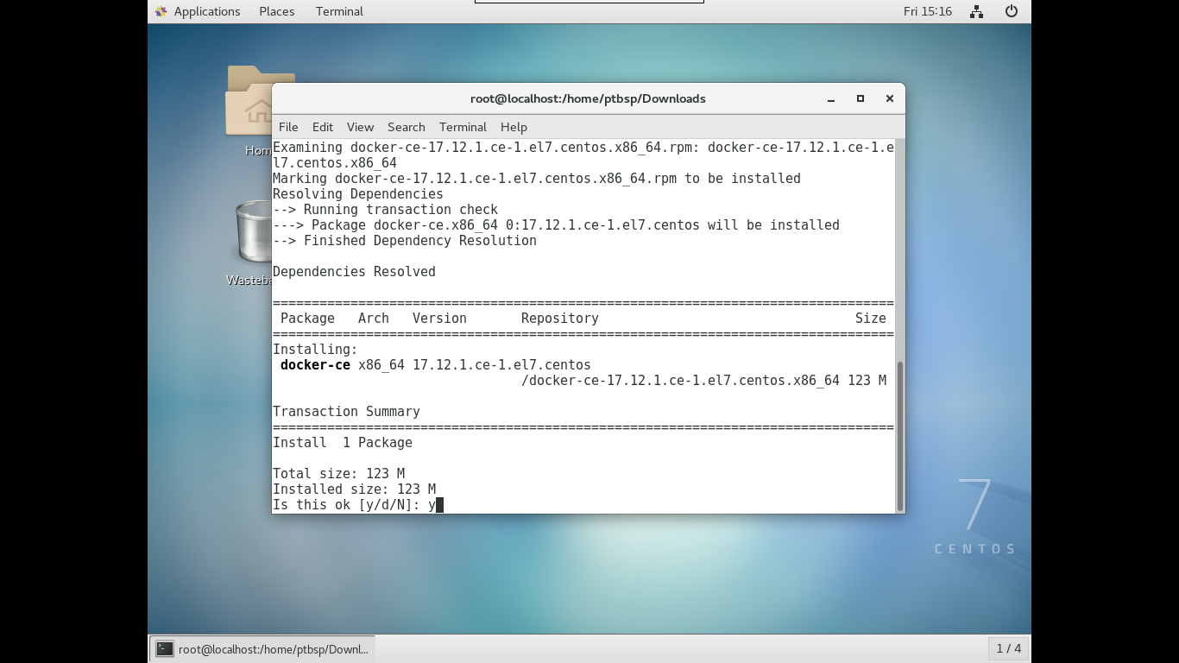

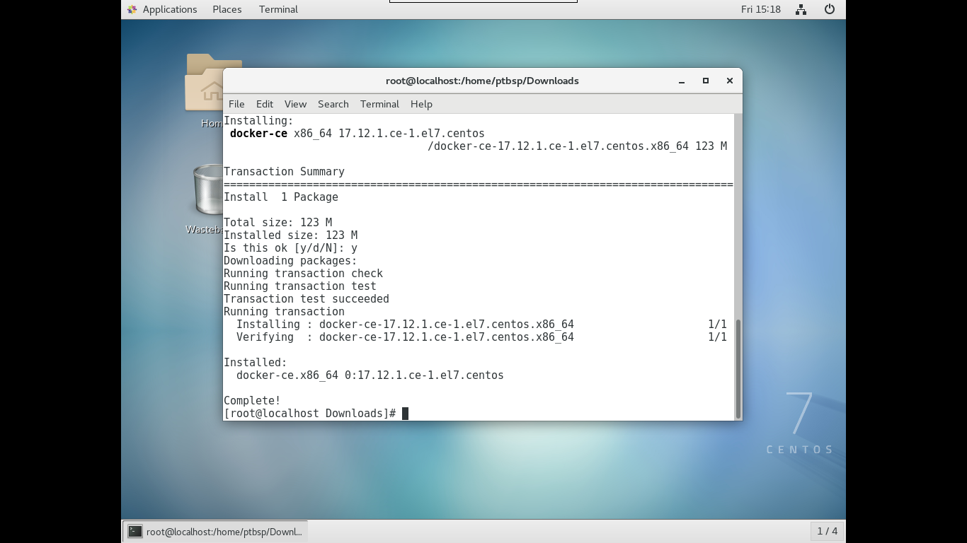

1. Enable dan Start docker

$ systemctl enable docker && systemctl start docker

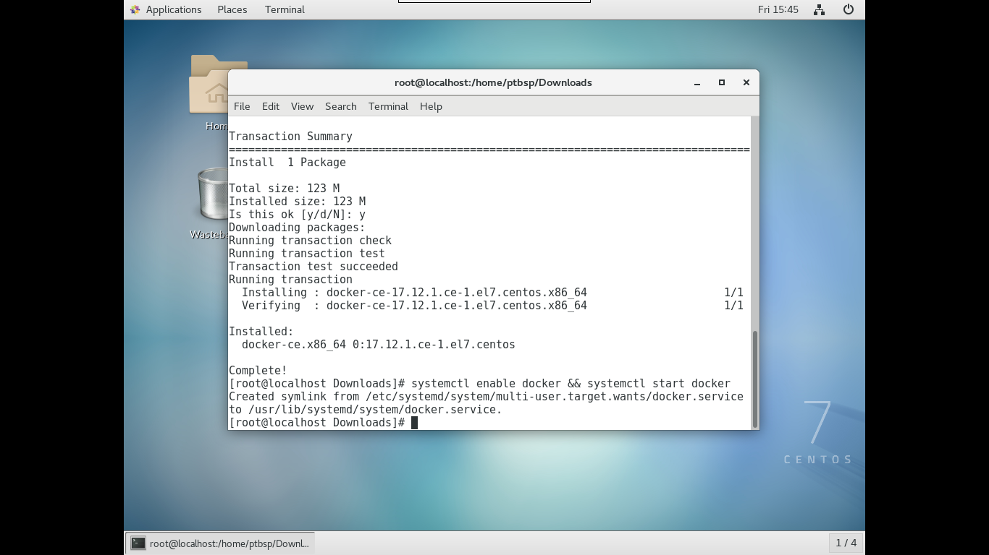

1. Install Openiron (pastikan Fnproject telah terinstall)

$ curl -sSL https://cli.iron.io/install | sh

$ curl -f -sSL https://cli.iron.io/install -O

$ sh install

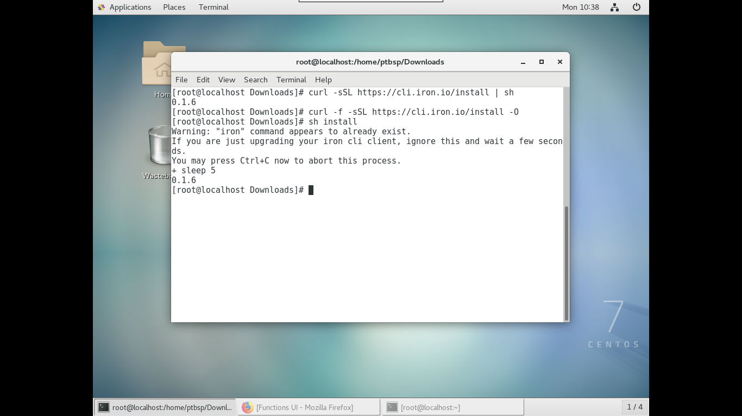

1. Register Openiron ke container docker

$ docker run --rm -it --name functions -v ${PWD}/data:/app/data -v /var/run/docker.sock:/var/run/docker.sock -p 8080:8080 iron/functions

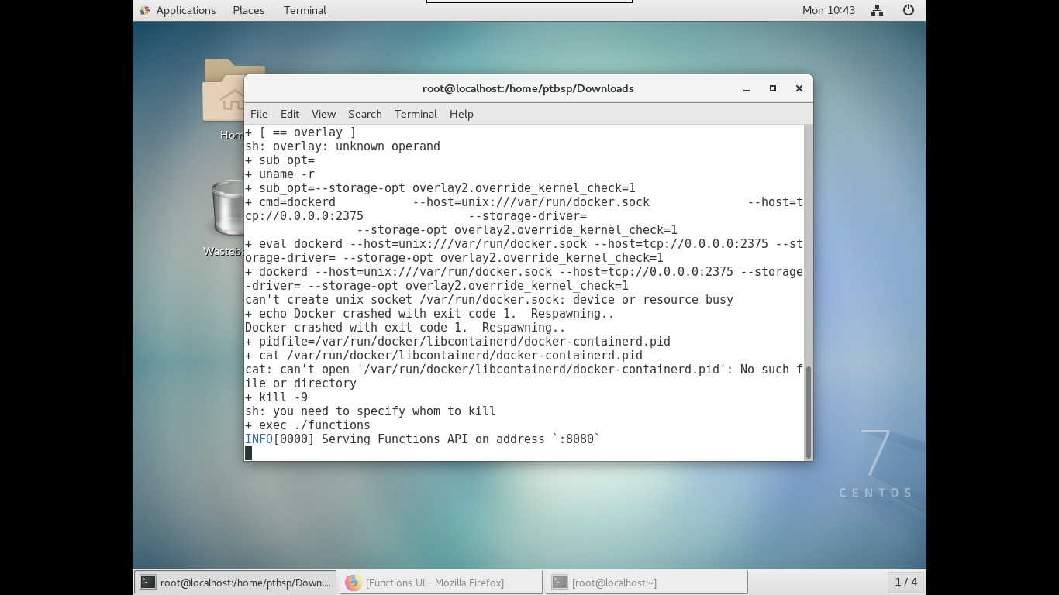

Akses portal Openiron dengan alamat http://localhost:8080 atau http://127.0.0.1:8080

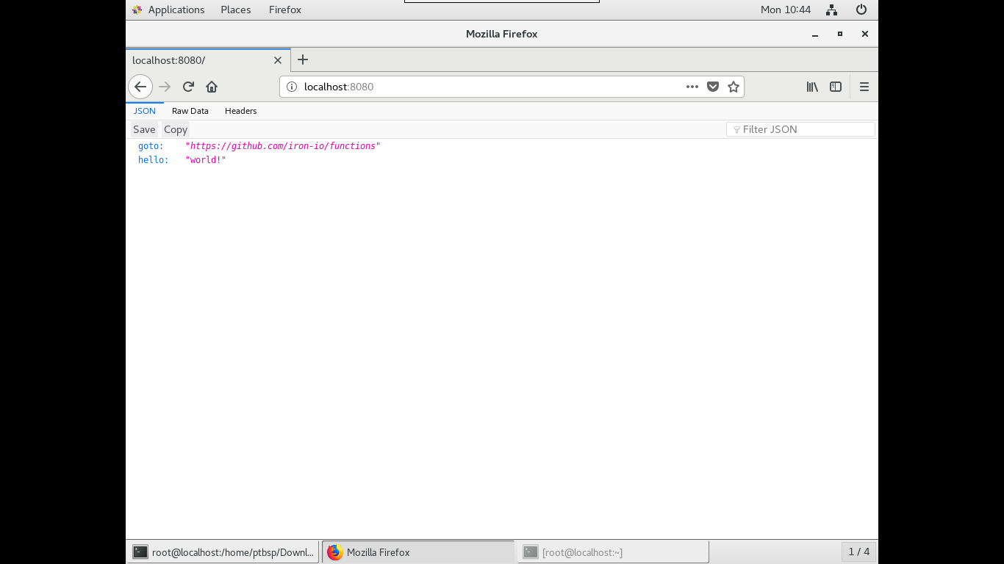

1. Install User Interface Openiron (pastikan sudah bisa mengakses portal seperti pada langkah no. 4)

$ docker run --rm -it --link functions:api -p 4000:4000 -e "API_URL=http://api:8080" iron/functions-ui

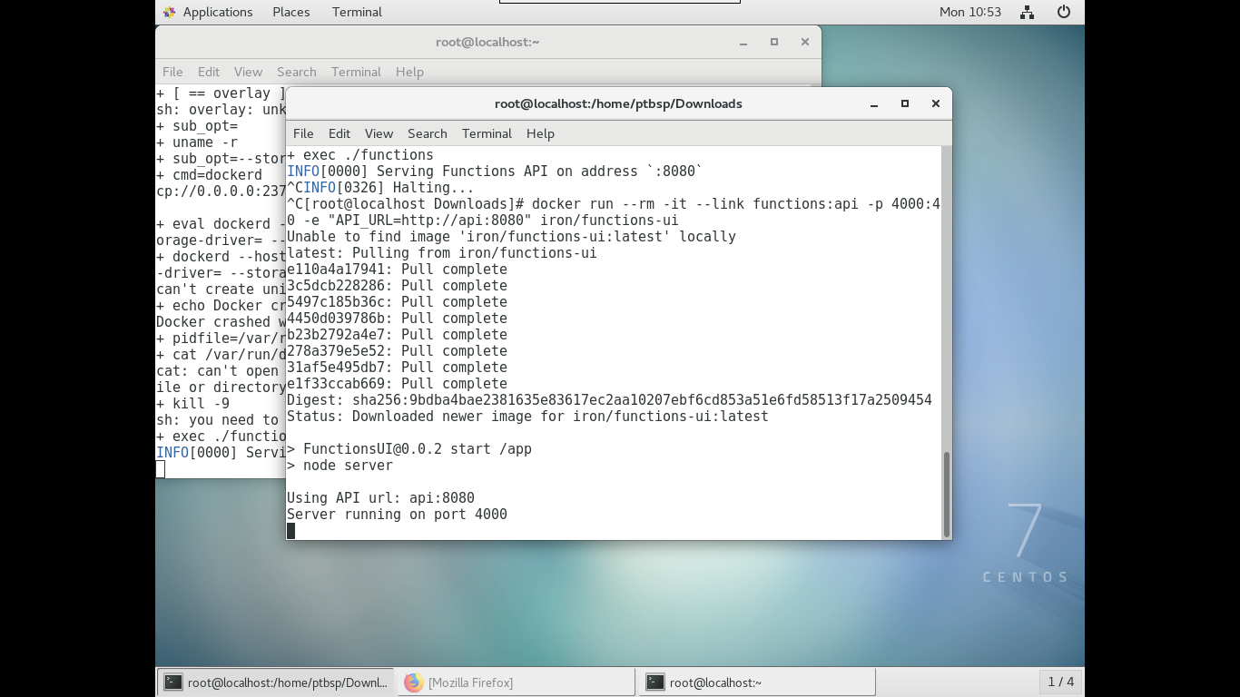

Akses portal Openiron dengan alamat http://localhost:4000 atau http://127.0.0.1:4000

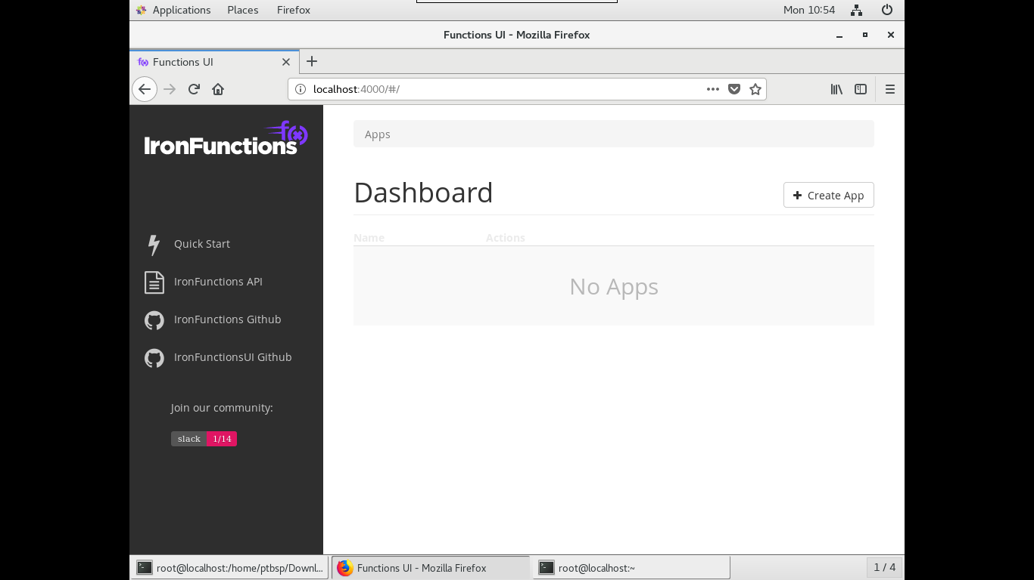

1. Create java hello world

$ mkdir iron-java-function

$ cd iron-java-function

$ fn init --runtime java hello-java

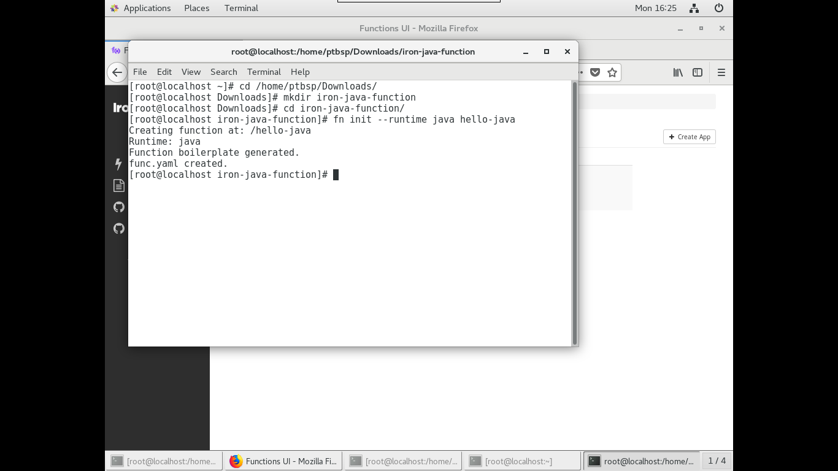

$ cd hello-java

$ fn run

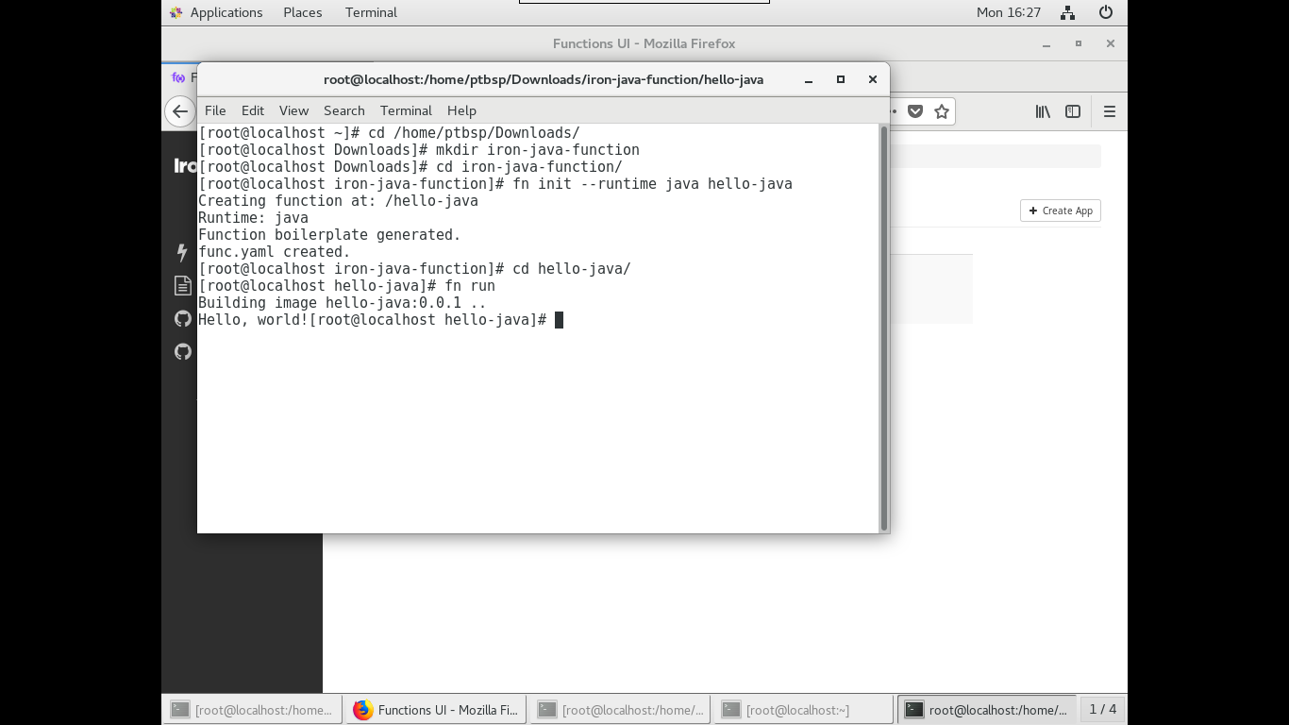

$ fn deploy --app hellojava --local (pastikan fnproject sedang running)

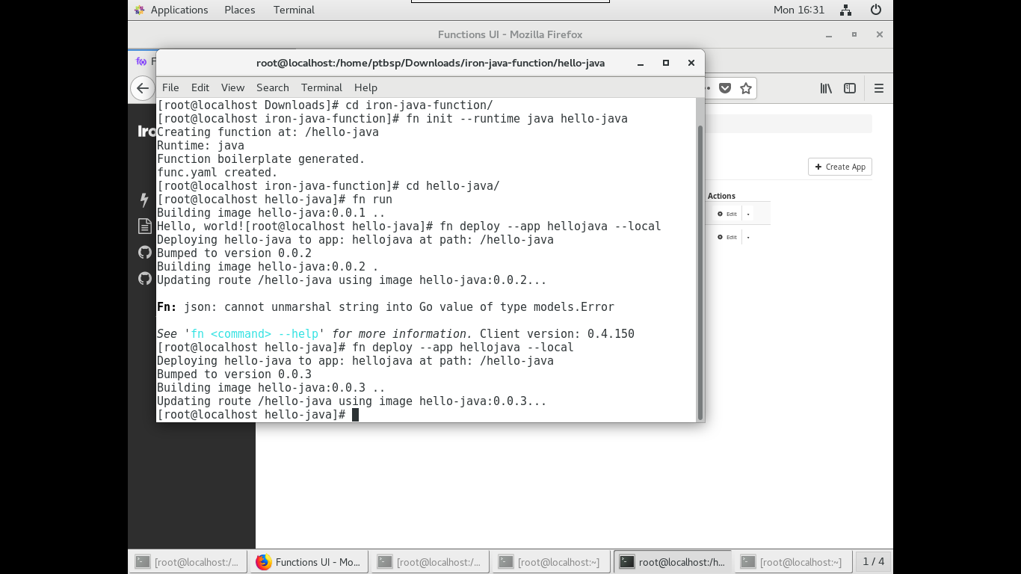

Run hello-java di Openiron User Interface

